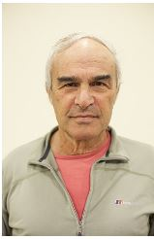

M. Iggy Litaor
Professor
Chairperson of the water sciences M.Sc. program
Head of the hydro-geochemistry laboratory in MIGAL - Galilee Research Institute http://www.migal.org.il/Iggy-Litaor
Department of Environmental Sciences
972-54-6780076
litaori@telhai.ac.il

Abbreviated personal biography
Ph.D., 1986 University of Colorado, Boulder CO, USA, In geochemistry
2010 - present, MIGAL, Head of the Hydro-geochemistry Lab.
2008–Present, Professor in Tel Hai College.
1996–2008, Associate Professor in Tel Hai College, Upper Galilee, Israel.
1995–1996 Adjunct Prof., University of Colorado, Department of Civil and Environmental Engineering.
1990–1995 Senior soil scientist, EG&G working in Rocky Flats Plant (RFP) on the fate and transport of radionuclides (Pu, Am & U) in soils.
1986–1990 Postdoctoral fellow, Institute of Arctic & Alpine Research University of Colorado, Boulder.
To date I have supervised 46 graduate students in Israel, Germany and USA

